**Case 2-ME-Mesopotamia-Sumeria-**Gudea-Foundation Nail-terracotta-2144–2124 BCE

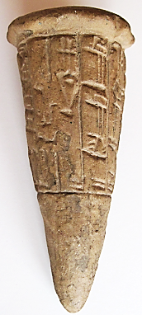 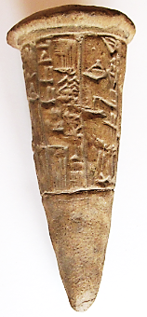 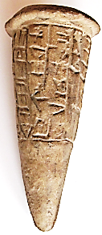

**Formal Label: Mesopotamia-Sumeria-**Gudea-Foundation Nail-terracotta-2144–2124 BCE

**Accession Number:**

**LC No.:** PJ4070.A1

**Formal Label:** **Mesopotamia-Sumeria-**Gudea-Foundation Nail-terracotta-2144–2124 BCE

**Display Description:**

Foundation nail dedicated by Gudea (r ca 2144–2124 BCE ) who named himself *ensi* or lord of plowland (but not *lu-gal* “man-big” or “big man”) of Lagash in S Mesopotamia. He became part of the royal house by marrying the daughter of the *lugal* of Lagash. Gudea built a temple to the city-god of Lagash [D](https://en.wikipedia.org/wiki/Dingir)[NIN](https://en.wikipedia.org/wiki/NIN_%28cuneiform%29).[ĜIR2.SU](https://en.wikipedia.org/wiki/Girsu) (Ningirsu) and that is the origin of this foundation nail that was placed in its walls as a dedication: "*For Ningirsu, the powerful hero of Enlil, his king, Gudea, prince of Lagash, accomplished what had to be; his temple of E-innu, the shining thunder-bird, he built and restored.*"

**Date or Time Horizon:** ca. 2144 - 2124 BCE

**Geographical Area:** Southern Mesopotamia

**Cultural Affiliation:** Sumerian

**Medium:** original, fired clay.

**Dimensions:** H 112.36 mm, 4.423 in; Dia 48.54 mm,1.911 in

**Weight:** 174 g, 6 1/8 oz

**Provenance:** old French collection

**Discussion:**

Ningirsu was a Sumero-Babylonian god of rain, irrigation, and fertility that evolved into Ninurta. He was the patron deity of the ancient Sumerian city of Girsu (Lagash) where king Gudea constructed a temple for him called the Eninnu. He had a field here where all sorts of plants flourished. He is a son of Enlil and a she-goat, and his consort is Baba. His name means "Lord of Girsu", and his symbol is the lion-headed eagle.

**References:**

Hibbard, Howard. 1980. *The Metropolitan Museum of Art*. New York: Harper and Row, fig. 112, p. 53.

Johansen, Flemming. 1978. *Statues of Gudea: Ancient and Modern*. Mesopotamia 6. Copenhagen: Akademisk Forlag

Metropolitan Museum of Art. 1970. *Masterpieces of Fifty Centuries*. New York: Dutton, no. 5, p. 78.

Mornand, Pierre. 1931. "Une Nouvelle Statue de Gudea." *Beaux-Arts*, March 1931, p. 26.

Redmond, Roland L., and James J. Rorimer. 1959. "Review of the Year 1958-1959: Report of the President and of the Director." *The Metropolitan Museum of Art Bulletin* 18 (2), Eighty-Ninth Annual Report of the Trustees for the Fiscal Year 1958-1959 (Oct.), p. 34.

Scheil, Vincent. 1930. "Nouvelles statues de Gudea." *Revue d'Assyriologie* 27 (4), pp. 163-164, pls. III, IV.  
Woolley, C. Leonard. 1935. *The Development of Sumerian Art*. London: Faber and Faber Ltd., pl. 61a,b.